

Capstone Proposal

Quiz Creator



April 11, 2021

MAN VU - 000801665

Table of Contents

Project Background 2

Functionality Chart 2

Development Stack 3

Overview of Application 4

Home Screen 4

Home Screen (Unauthenticated) 4

Home Screen (Authenticated) 5

Register Screen 6

Login Screen 7

View User Profile Dropdown Menu 8

Profile Settings Screen 9

Quiz Screen 10

Quiz Screen (Multiple Choice Question) 10

Quiz Screen (Gap filling Question) 12

Quiz Screen (Matching Question) 13

Quiz Result Screen 14

Discussion Forum 15

Main Screen 15

Create New Thread Screen 16

Thread Screen 17

User Statistics 18

Administration Screen 19

Admin Screen - Manage Quizzes 19

Admin Screen – Manage Questions 21

Admin Screen – Add/Edit Question – Multiple Choice 22

Admin Screen – Add/Edit Question – Gap-filling Questions 24

Admin Screen – Add/Edit Question – Matching Questions 26

Board Statistics 27

Entity Relationship Diagram 28

Test Plan 29

Test to Pass 29

Test to Fail 31

Project Plan Development 32

# Project Background

Over the last 30 years, humans have witnessed relentless technological advances in pedagogical methods. One of the most innovative ways to transmit knowledge in the modern world is to use electronic learning system, better known as e-learning system. This method of knowledge transfer and acquisition has become popular and been widely used at many institutions across the globe in the information age, especially during the COVID-19 pandemic age, where face-to-face traditional classes have been rendered next to impossible due to the risk of viral infection. Inspired by popular e-learning systems, such as MyCanvas and Desire2Learn, this quiz manager application is specifically designed to facilitate language learning. The web application will be developed using Vue and MySQL.

# Functionality Chart

|  |  |  |
| --- | --- | --- |
| **Feature** | **Regular User** | **Admin** |
| CRUD on quizzes/questions (main collection) |  | X |
| Search filters on quizzes (based on question text) | X | X |
| Rating system (give rating after submitting a quiz) | X | X |
| Rating system (sortable, filterable) | X | X |
| Rating system (reset ratings) |  | X |
| Favorite system (making quiz as favorite for quick access, filterable) | X | X |
| Create post in discussion forum | X | X |
| Reply to post in discussion forum | X | X |
| Delete posts in discussion forum |  | X |
| Individual statistics in pie charts (showing the number of correct and incorrect answers, the number of quizzes taken) | X | X |
| Board statistics in pie charts (showing the number of correct and incorrect answers from all users per question) |  | X |

# Development Stack

|  |  |
| --- | --- |
| **Technology** | **Intended use in application** |
| HTML / CSS | The backbone of the front-end side. |
| Bootstrap | The CSS framework responsible for creating responsive elements so that the application looks nice and user-friendly on devices of different screen sizes. |
| Node.js | The back-end side of the application intended for handling requests from the front-end side on different endpoints, performing actions based on the routes, and communicating with MySQL database. |
| Vue | The JavaScript framework for the front-side responsible for creating and dividing the web application into different components, each of which is used for rendering part of the website. Vue Router is used to for routing and site navigation. Vuex is a state management library that stores the different of the application which can be accessed in different components. |
| MySQL Workbench | Tool used for manage MySQL relational database |
| GitHub | Version Control |
| Nightwatch.js | Automated end-to-end testing library for JavaScript framework |
| Microsoft Azure | For deploying the finished application to production |

# Overview of Application

## Home Screen

### Home Screen (Unauthenticated)

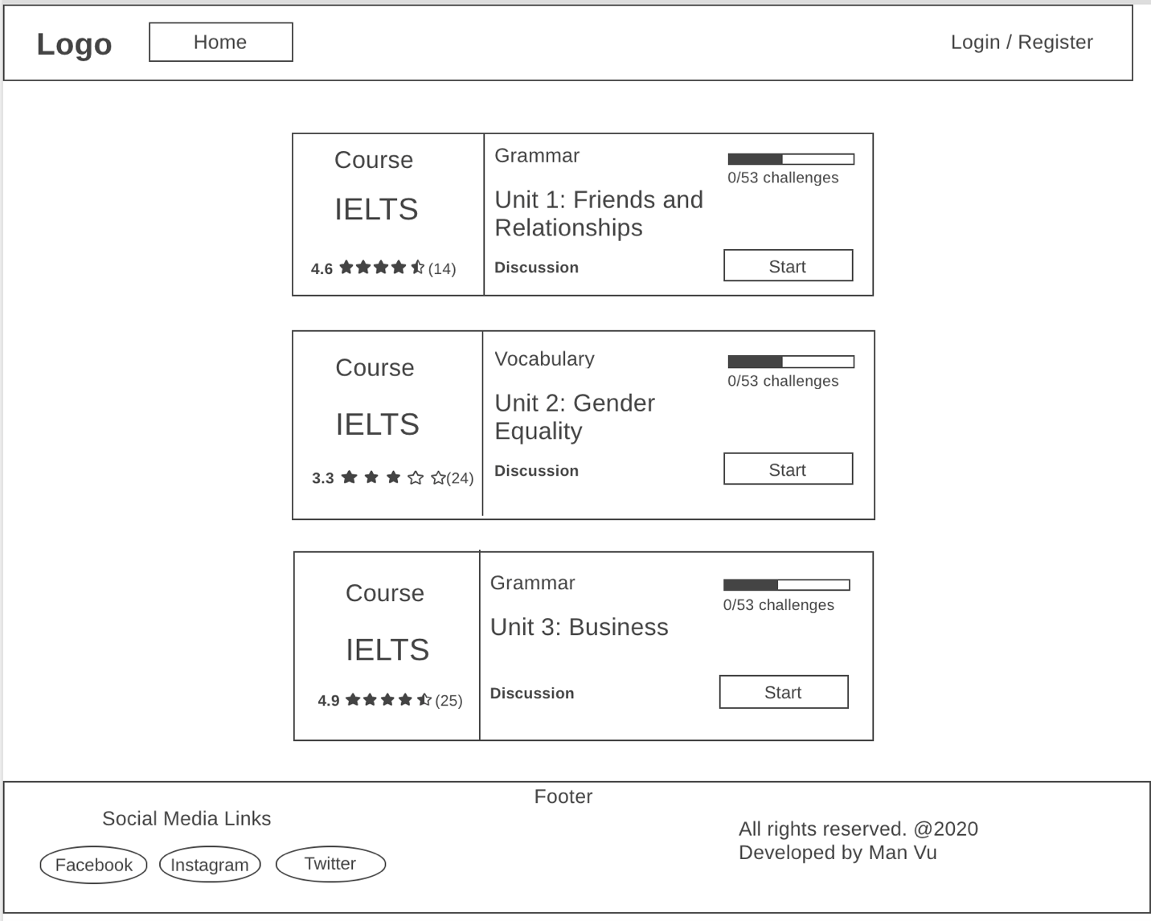

When a public user arrives at the website, this is the first page that is presented to them. While what they see looks nice and appealing, they are not allowed to start one of these quizzes by clicking on either “Discussion” link or “Start” button until they have registered and become a regular user of the site. If public user tries clicking one of these links and buttons, the site will redirect them to the Login screen start the authentication process. Likewise, if they try to access one of protected routes that are intended for registered users and admins, such as /admin or /statistics, the site will redirect the user to the login screen and ask user to authenticate themselves.

The reason login and register screens are not set as the entry point of the application is attributed to the fact that visitors should have a good idea of what the site is about before deciding to register. Additionally, even though there are many items in the navigation bar, they are hidden as the user is not currently authenticated.

In the bottom of the site lies the footer where site information is located along with social media links.

### Home Screen (Authenticated)

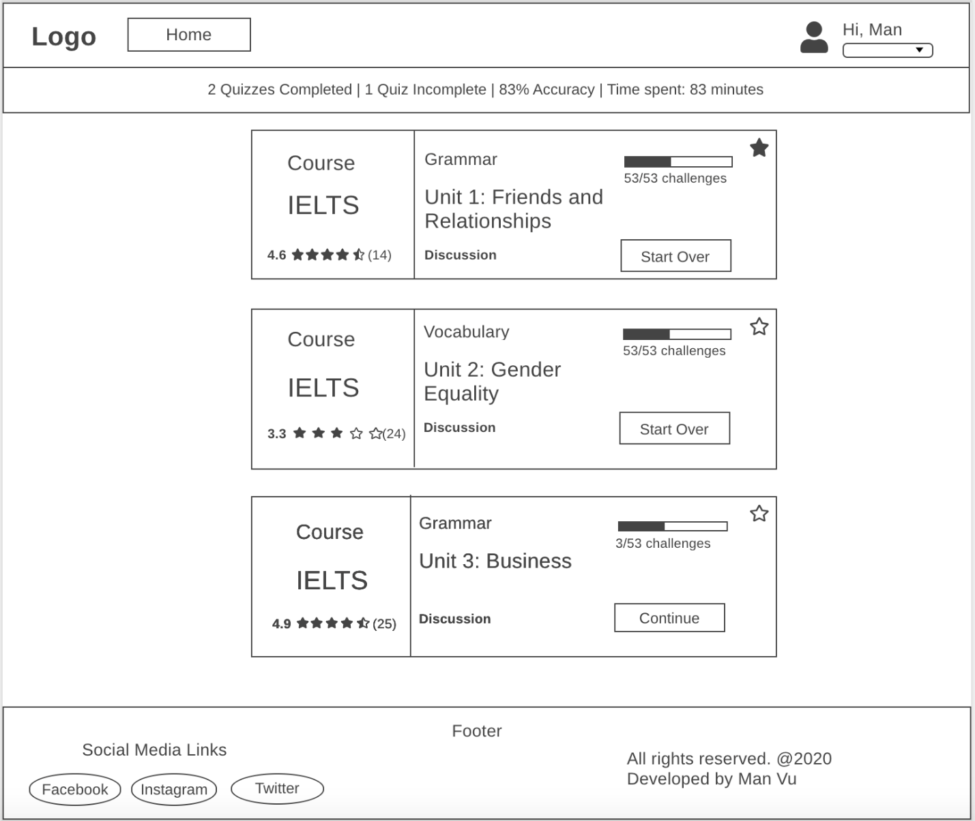

This is the home screen when user has successfully logged in their account. Unlike when user is unauthenticated, the “Login / Register” button on the right-hand side of the navigation bar is replaced with a greeting message along with the user’s profile picture and a dropdown button, which will be discussed later in this document. In addition to these changes, a new status bar that displays a brief overview of user statistics now appears under the navigation bar. Information about the numbers of completed and incomplete quizzes, the average accuracy of their answers, and the total amount of time spent on these quizzes is displayed inside the status bar. If user clicks on one of these numbers, the site will redirect them to the user statistics screen, where they are presented with detailed information about their performance over time. The router link to the user statistics screen is in the navigation bar and will be displayed and discussed later.

Furthermore, when user is authenticated, they are allowed to add any of the quizzes to favorites by clicking on the star in the top-right corner of the quiz card. Also, their progress on each quiz that they have taken are reflected in a progress bar on that quiz card as well.

## Register Screen

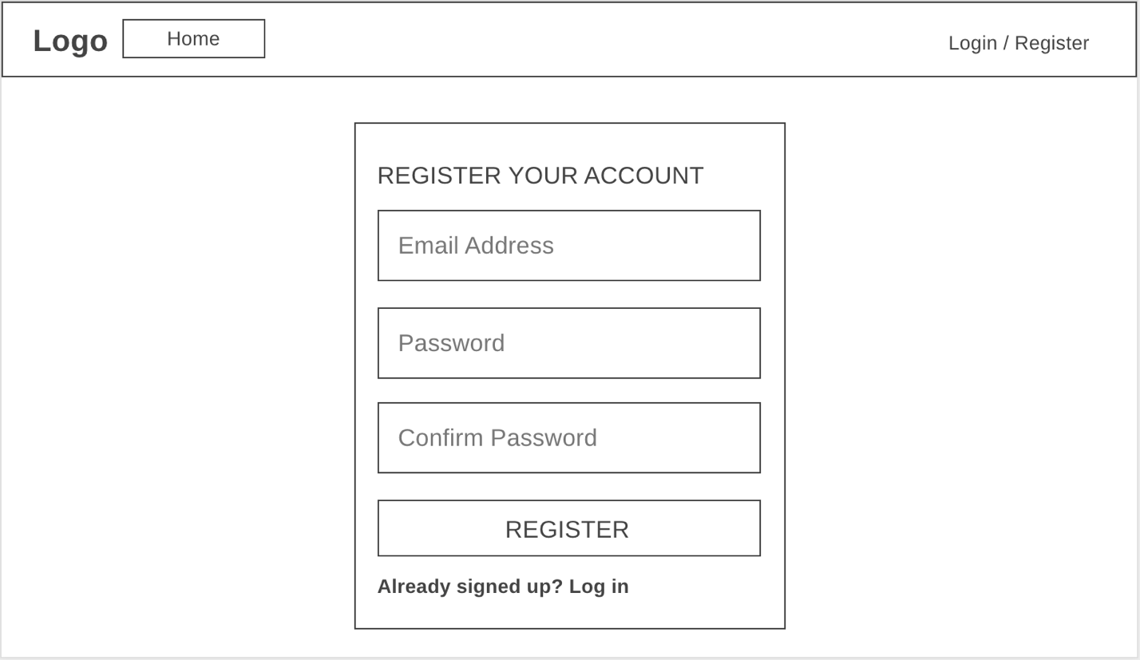

When user first arrives and clicks on the Register button in the top-right corner, a new modal will open up and asks for basic information, like email and password. There will be validation to ensure the following requirements are met:

* Email has not been taken by any other user
* Email must be in the proper format (using regex to achieve)
* Password must be at least 8 characters
* Confirm password must be matched with password

If any of these requirements is not satisfied, an error message in red will display above the input form where user makes mistake and ask user to re-enter that information.

If all information entered by user is good, a new user will be registered and they will log in as the user, and at the same time, the site will redirect them to the home screen where they can begin their journey.

In case user clicks on “Already signed up? Log in”, the site will replace the Register modal with the Login modal.

## Login Screen

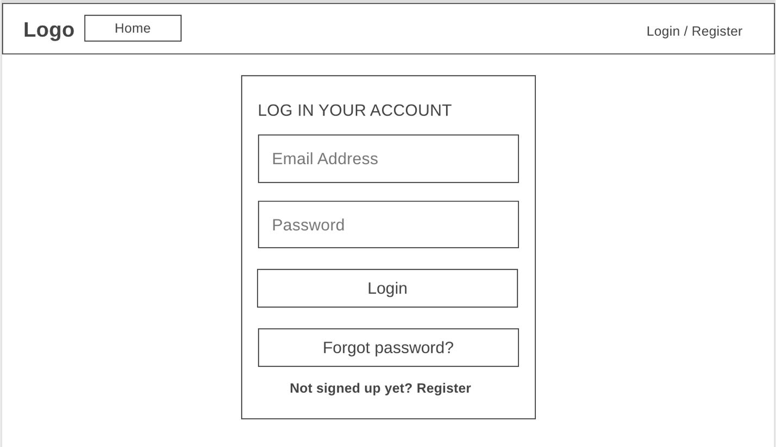

This is the Login modal where user enters information, including email address and password that they have entered when registering their account, to log in their account. There is also validation that makes sure that the following requirements are met:

* Email must be in the proper format (using regex to achieve)
* Password must be at least 8 characters

Like the Register screen, error message will appear and asks user to re-enter their information if either of them is incorrect.

If user has not registered their account, they should do so by clicking the link “Not signed up yet? Register” in the bottom of this modal.

If user has forgotten their password, they can set a new password by clicking on the “Forgot Password?” button and follow the instruction in that screen, which will be discussed later.

If everything is all good, user will be redirected to Home Screen after clicking on the Login button.

## **View User Profile Dropdown Menu**

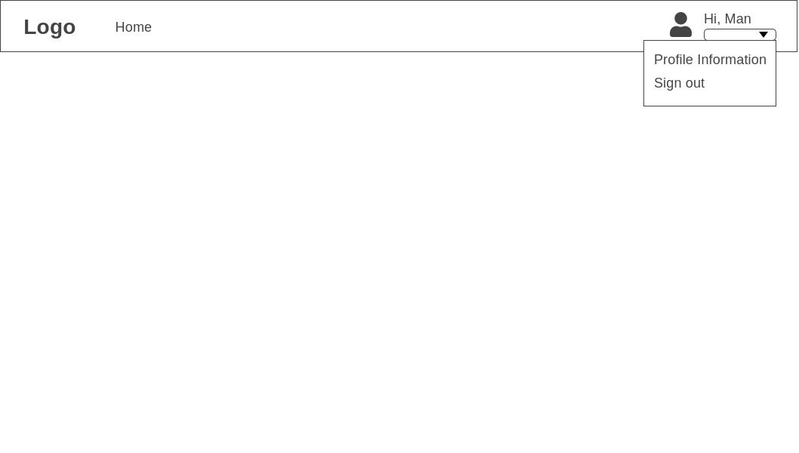

When user clicks on the dropdown menu in the top-right corner, two options will pop up. User can choose to edit their information like email, first name, last name or password or they can choose to sign out.

## **Profile Settings Screen**

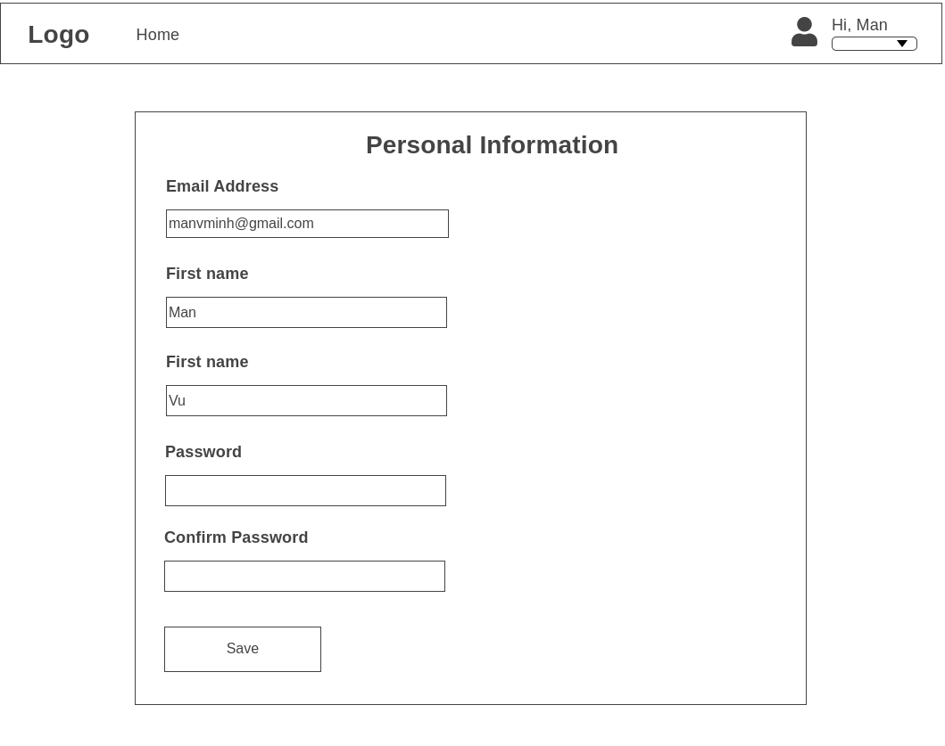

User can access this screen by clicking on “Profile Information” in the dropdown box beside the profile picture. In this screen, user can change their basic personal information. However, the information entered by user has to conform with the requirements in the Register screen. Also, the first name and last name input forms cannot be left blank.

## **Quiz Screen**

### **Quiz Screen (Multiple Choice Question)**

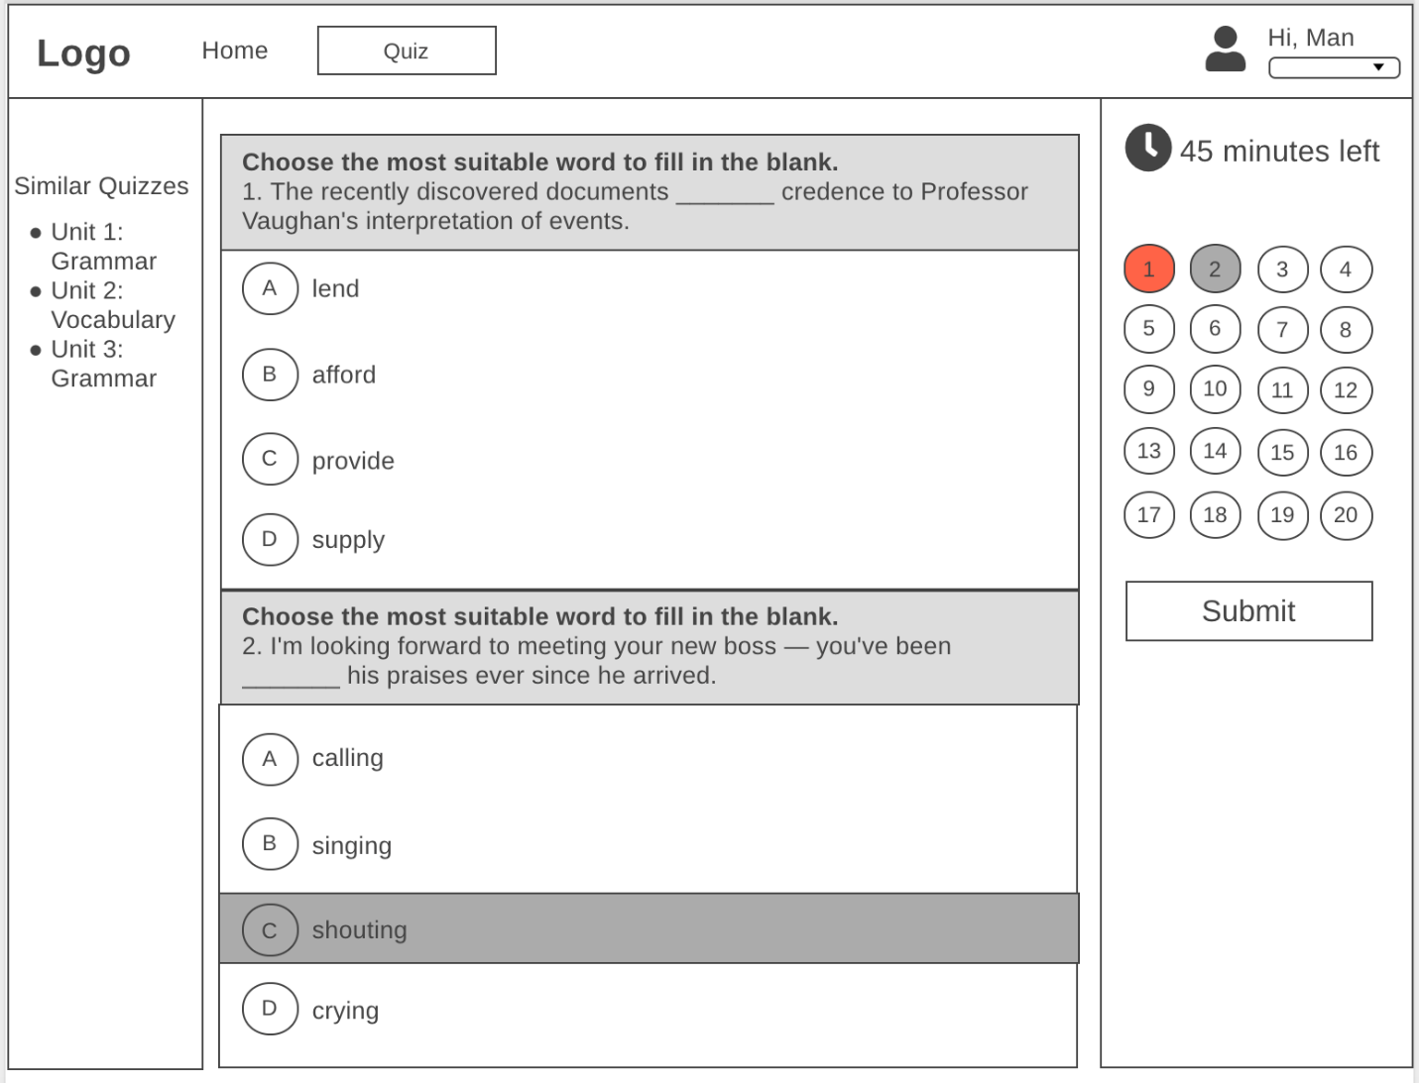

This is the main screen that hosts the implementation of the core functionality of this application.

In the left sidebar of the page, user is suggested with quizzes that they have not taken. Clicking on one of these quiz links will pop up a message that asks user whether they really want to save their current attempt for the current quiz and switch to the selected quiz.

In the right sidebar of the page, there is a countdown timer that displays the number of minutes or seconds left until the end of the current attempt. As soon as the timer hits 0 second left, the site will automatically all of their answers no matter whether user has answered or not. Below the timer is the question palette and you can navigate to the question number that they want by clicking on one of the numbers in the palette. Also, another important item is the Submit button. If user clicks on the button, they will be asked whether or not they want to submit their work because this action cannot be undone. If user clicks on Yes, they will immediately see the result of their attempt along with their correct and incorrect answers.

This center of the screen houses the main body of the page, the quiz part. One of the most common question types is multiple choice, and this one is the most simple and straightforward, so this will be introduced and discussed first. Each of the multiple-choice questions is presented in a question card that includes the header and body part. While the header contains the instruction and question, all of the choices are listed in the body part. As soon as user makes a choice, the selected option will be highlighted and the quiz will be saved just in case the user disconnects from the site.

In case of disconnection, user can reconnect and resume their current attempt without having to start over and the time remaining continues to decrease without being reset.

### **Quiz Screen (Gap filling Question)**

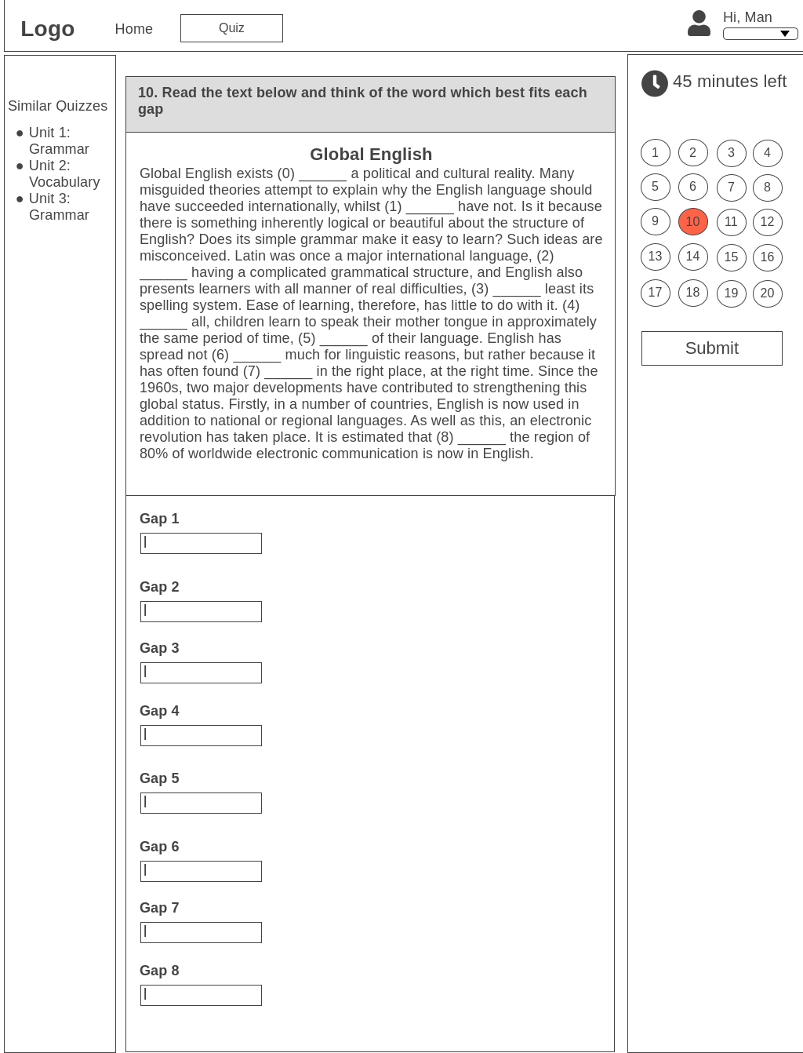

As for the gap-filling questions, user is presented with instruction for the question in the header the question card, a paragraph or sentence with blanks with numbers and the text boxes for entering their answers below the question header. There is no validation for these input text boxes because answer can be text or numerical, which is determined by the admin who has created the quiz. Additionally, user’s answers are saved on the server side every time user triggers key-up event of each of the textboxes.

### **Quiz Screen (Matching Question)**

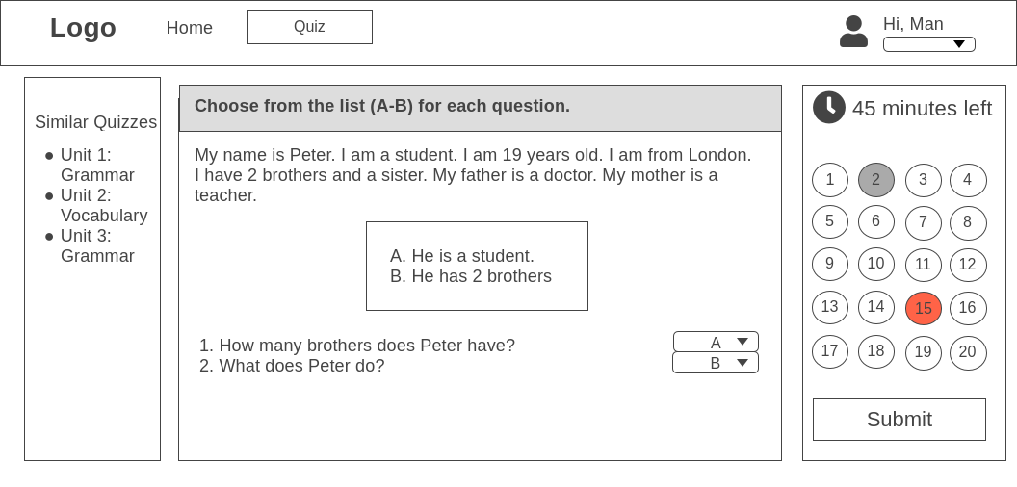

In regards to the matching questions, user is presented with instruction for the question, paragraph that contains information to answer the questions. Below the paragraph is an option box that contains a list of available options, each of which is assigned a letter for identification. Below that is a list of questions and there is a dropdown box associated with each of the questions. The dropdown boxes contain all available options in the option box above it. User answers by choosing the most suitable option for each question. Also, user’s answers are saved on the server side every time user triggers key-up event of each of the textboxes.

### **Quiz Result Screen**

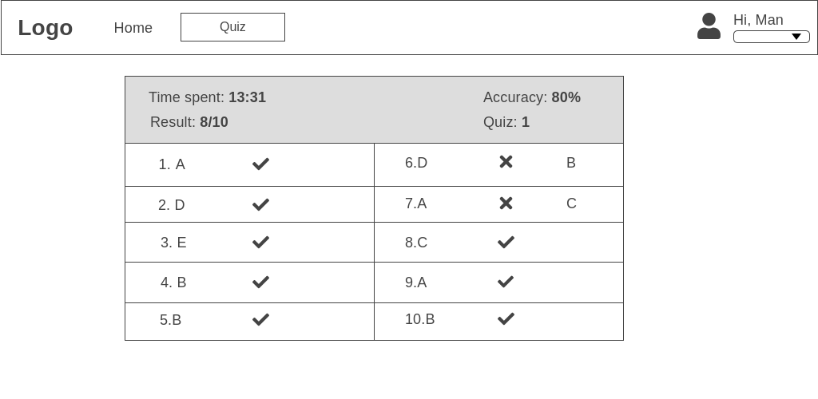

This is the Quiz Result screen which will appear after user has submitted their quiz. Using this screen, they can see which answers are marked correct and incorrect.

## **Discussion Forum**

### **Main Screen**

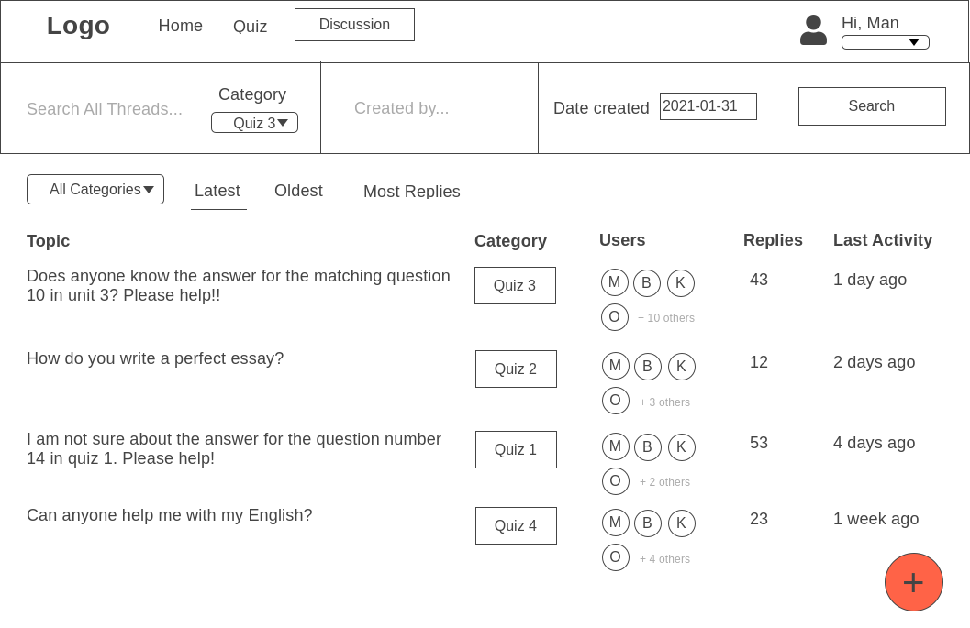

This is the main page of the discussion forum. User can access it by a couple of different ways, one is by the navigation bar and the other is clicking on the discussion link on any quiz card in the Home screen. The second method triggers the site to pre-filter the topic by category is related to the quiz number that user has selected. For example, if user has selected the “Discussion” link in the quiz number two, they will be presented with a list of threads that are related to quiz two only. Also, the category dropdown box is assigned “Quiz 2” as well in this case.

Using this discussion forum screen, user can apply multiple filters that allow for scalability and flexibility. They can do so by entering the keyword for searching threads, the name of the people who have created threads, and the created date of the threads in the top bar of the site. As soon as they are happy about the filters, they can perform a search by clicking on the Search button. Following this, the list of discussion threads below will be filtered by the predicate user has set.

As for sorting search results, discussion threads are sorted by last activity time by default. However, user can sort by the oldest threads and threads with most replies by clicking on one of sorting by texts, including “Latest”, “Oldest” and “Most Replies”.

Discussion threads are listed along with their category which are quiz numbers they are related to. Also, the profile pictures of users who have participated in threads are listed in the Users column. Each thread also has the number of replies and the last activity time which is the date time of the last reply to the thread.

If user wants to read a thread, they can click on the title of the thread, and then they will be redirected to the Thread screen, which will be introduced and discussed later.

If user would like to create a new thread, they can click on the big “+” button in the right bottom corner of the site, and they will be redirected to the Create Thread screen to create a new thread.

### **Create New Thread Screen**

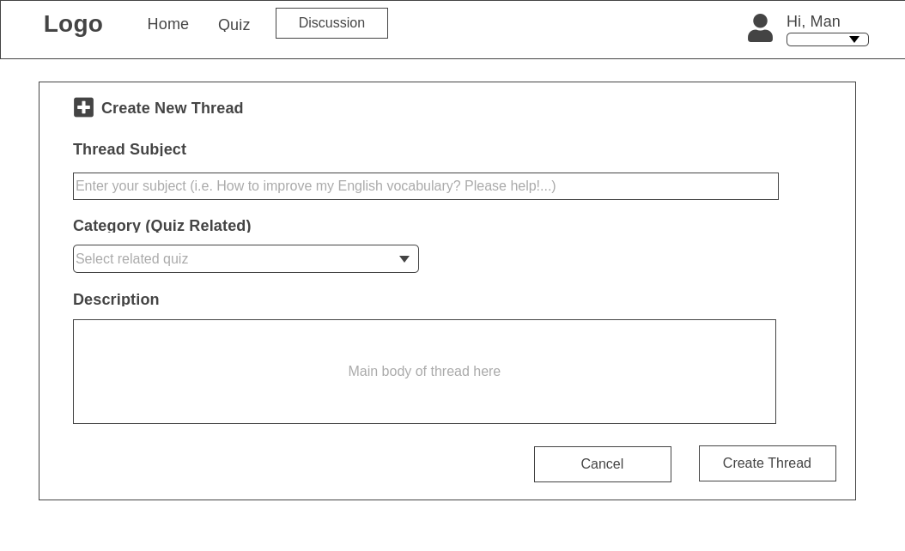

This screen appears as soon as user has selected the big “+” button in the main screen of discussion forum. This route is protected and public users cannot access it without authentication first. On the top of the screen is page title “Create New Thread” to let user know that they are creating a new thread. Below the title are an input form that accepts text and numerical input and Category dropdown that is pre-fetched and pre-filled with all quiz numbers that are currently active. Below the “Description” is a text area that accepts multi-line input from user. What is entered in this text area will display exactly as it is in the Thread screen which is introduced in the next section.

The “Cancel” button will allow user to discard their all of their input and go back the main discussion forum, while the “Create Thread” will create a new thread with information entered by user.

### **Thread Screen**

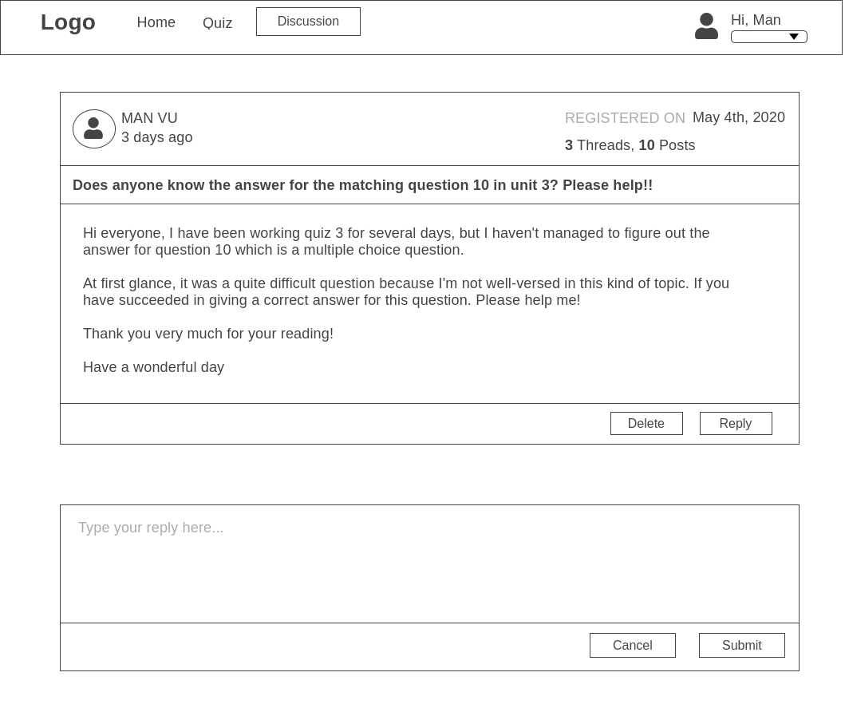

This thread screen appears when user has just created a new thread or clicked on one of the topic titles in the main screen of discussion forum. The style of this screen is intuitive and easy to understand since it is developed as simple as possible to just provide core functionality of a discussion forum. More specifically, basic information about the owner of a thread or a post appears in the header section of their thread or post, while the main body contains the content of their thread or post and the bold text below the header section wraps the subject of this thread. User can create post and reply to this thread by clicking on the “Reply” in the bottom right of the thread.

Only administrators can see the “Delete” button for each post, which allows them to remove posts that are considered inappropriate. If regular users are trying to fire a request to delete posts, they are prohibited from performing that action.

## **User Statistics**

## **Administration Screen**

This is the administration site of the page which is a protected route and can only be accessed by users with the “administration” role. Regular users and public users cannot either see “Administration” on their navigation bar. There is a left sidebar in this screen which is Admin Panel which allows administrators to easily create, update and delete quizzes and questions and view the overall statistics of the site.

### **Admin Screen - Manage Quizzes**

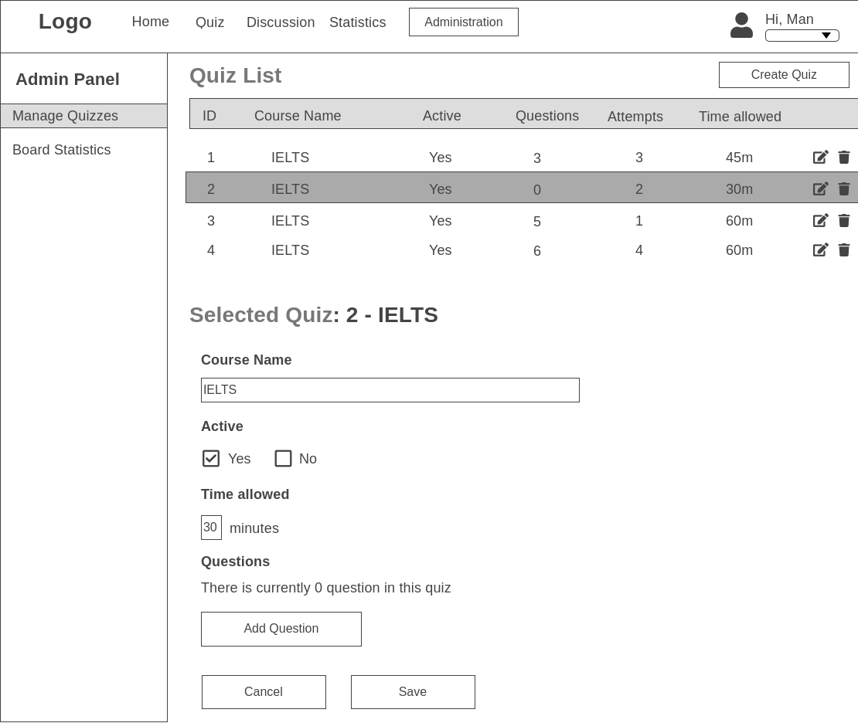

This is the default page administrations will see when they access the “Administration” route. The list of all quizzes will be populated in the quiz list table, and if there are more than 10 quizzes in the database, they will display in paginated list with 10 items per page. Important information about each quiz appears in the table along with two buttons, edit and delete, which allow administrators to edit or delete quizzes.

If they click on the edit button of a quiz, all the details about the quiz will display in an editable form which is located below the quiz list, and the quiz number and course name will display after the “Selected Quiz” text. Active quizzes will display in the home page and can be taken by users, while inactive are hidden and inaccessible.

If there is no question has been created for the quiz, the text “There is currently 0 question in the quiz” will display.

### **Admin Screen – Manage Questions**

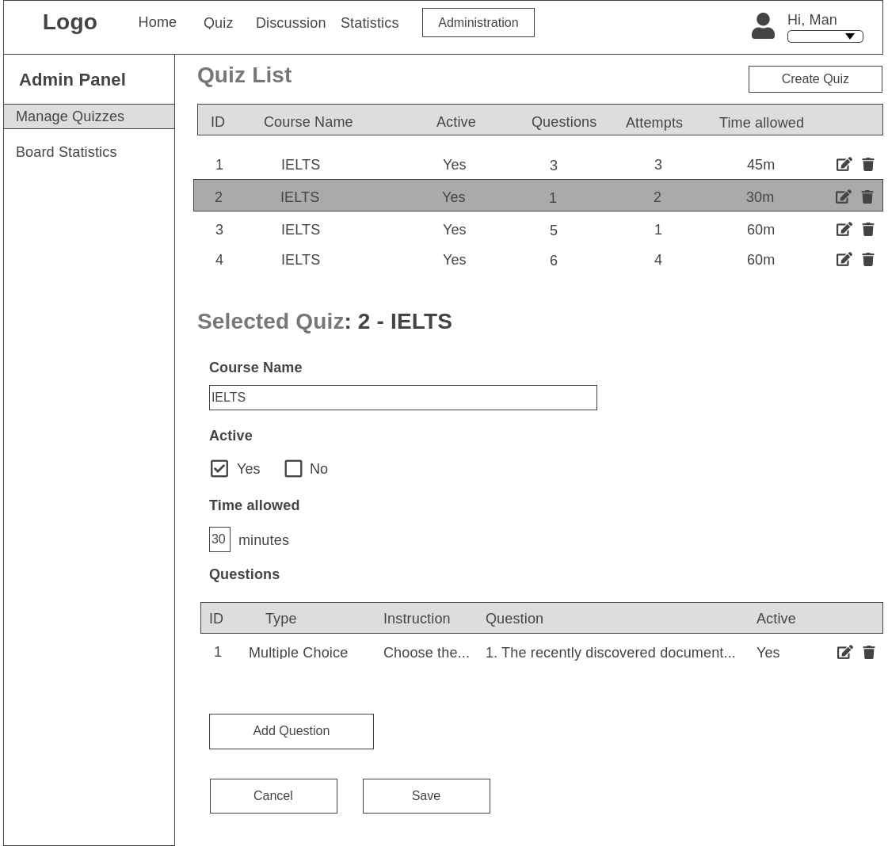

If there are questions in the quiz, they will display in table format. Like the quiz list, if there are more than 10 questions in the quiz, they will display in paginated lists for the sake of scalability. There are also edit and delete buttons associated with each question that allow administrators to either edit and delete the question.

### **Admin Screen – Add/Edit Question – Multiple Choice**

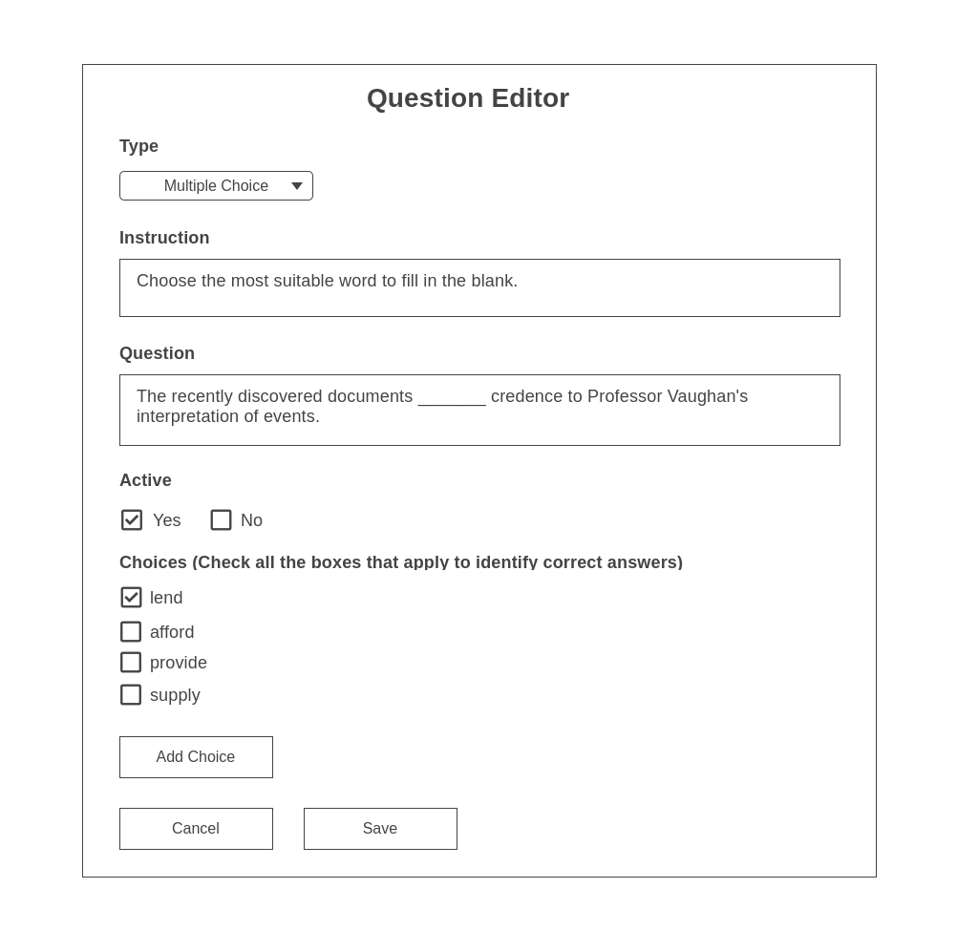

As soon as selects the edit button or the “Add Question” button, a modal named “Question Editor” will appear. Depending on whether the administrator is editing a question or creating a new question, the editable form will be filled in.

If the question is being edited, the administrator cannot change the type of the question because may be causing a lot of complex issues in the database and it is much more useful to create a new question with a different question type. All question types have the same input forms for Instruction, Question, and Active. While the first two will be displayed in the header of question card, the Active checkbox determines whether or not the question should be included in the quiz and shown to quiz takers.

As for the multiple-choice question type, admins can add new choices by clicking on the “Add Choice” button and identify the correct answers by checking the boxes.

### **Admin Screen – Add/Edit Question – Gap-filling Questions**

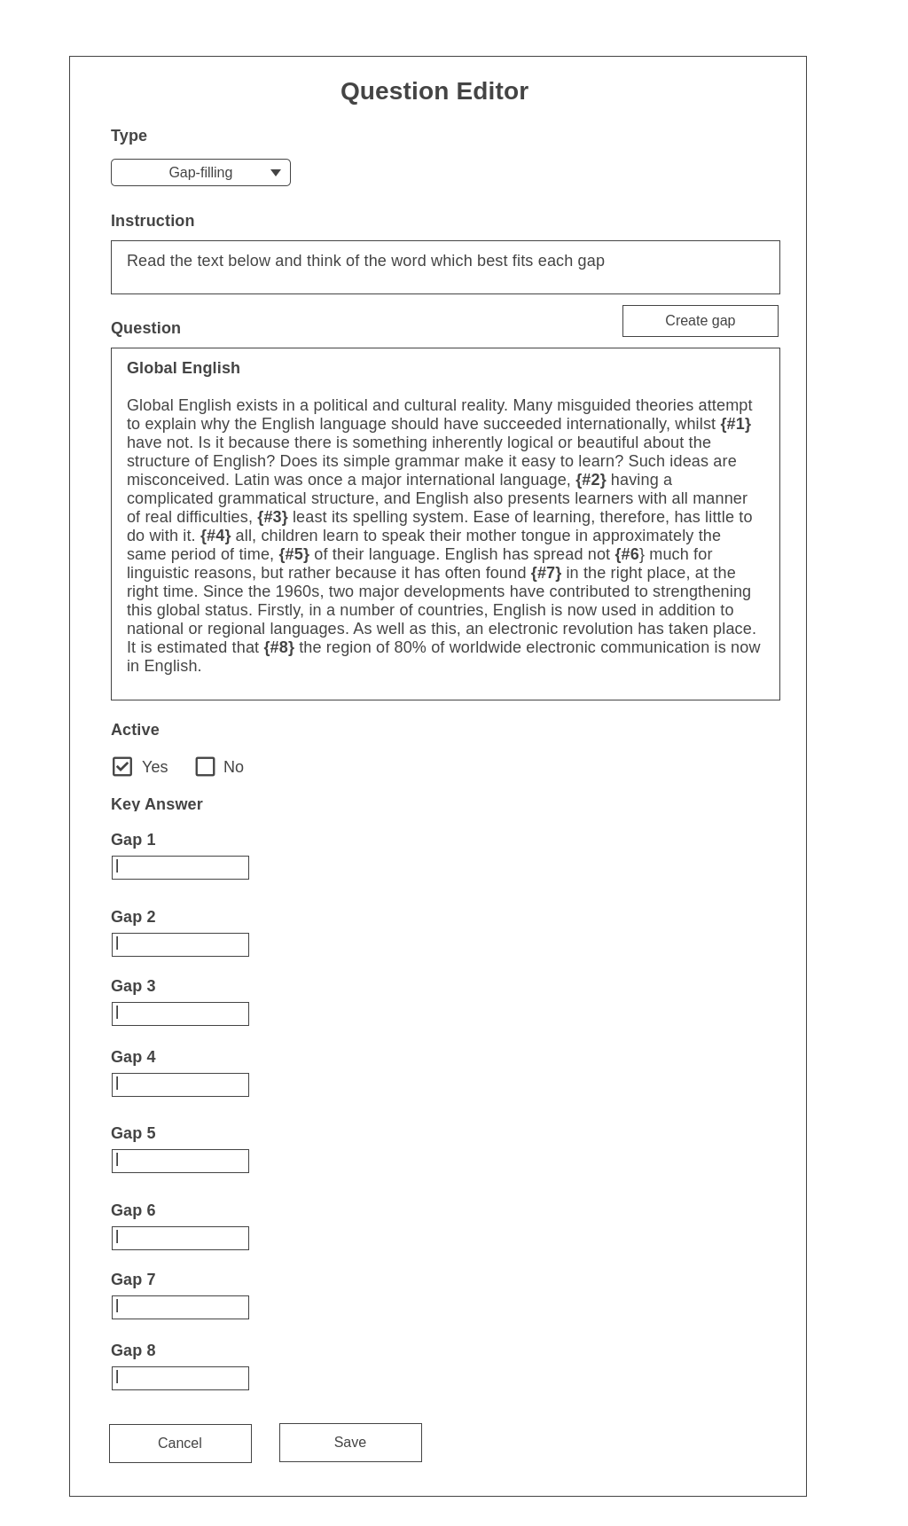

As for the gap filling question type, admins create new gaps for filling in by using “Create Gap” button. By clicking on the button, a new series of special characters will be inserted into the text area for question to let the system know that is a blank for filling in. If admins are not very happy about the blank, they can delete the gap by just deleting the special characters that have been created by the system. Also, as soon as admin has created a gap, a new text input form will be also created for giving correct answer. There is also validation that ensures everything in the question text area in the proper format before the question is added to the database.

### **Admin Screen – Add/Edit Question – Matching Questions**

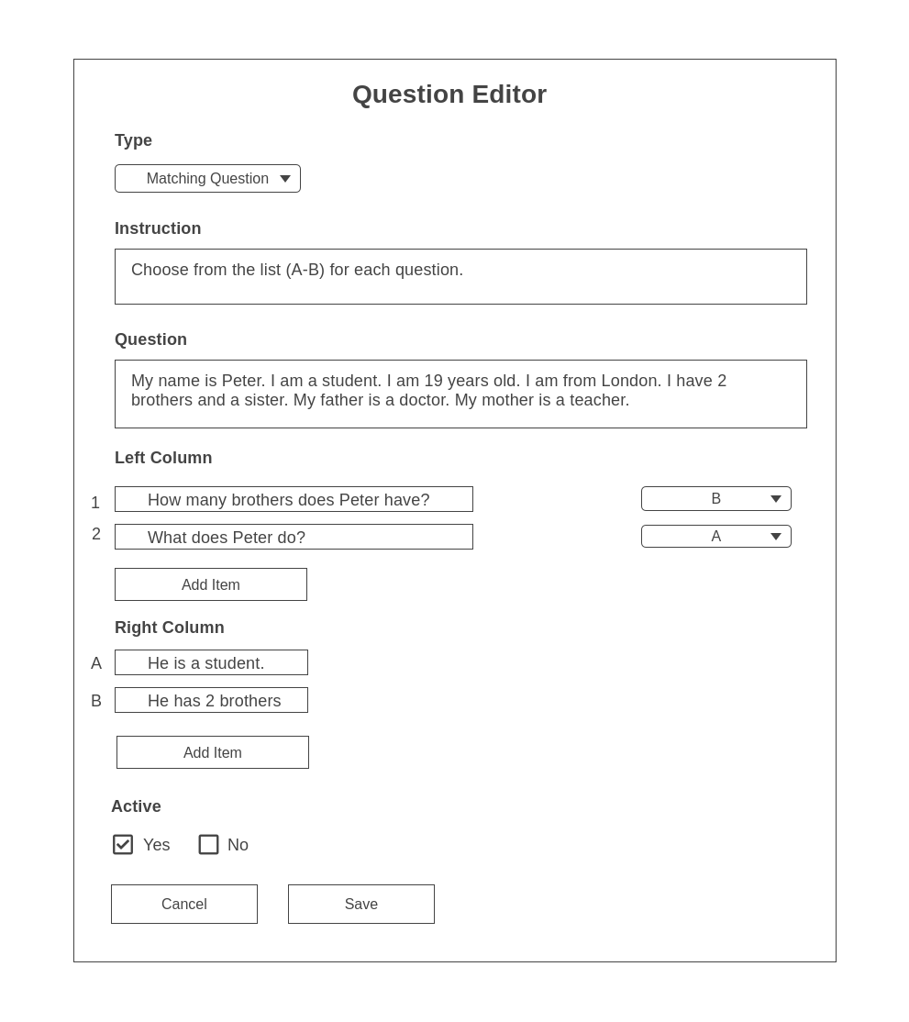

In regards to matching question type, admins can create as many items as they want for left column and right column by using the “Add Item” buttons. However, there is validation that makes sure that all items in left column have corresponding responses from the right column. The dropdown boxes on the right-hand side of items in the left column are automatically updated when new items are added to the right column. Admins can select any matching item for these dropdown boxes.

### **Board Statistics**

# Entity Relationship Diagram

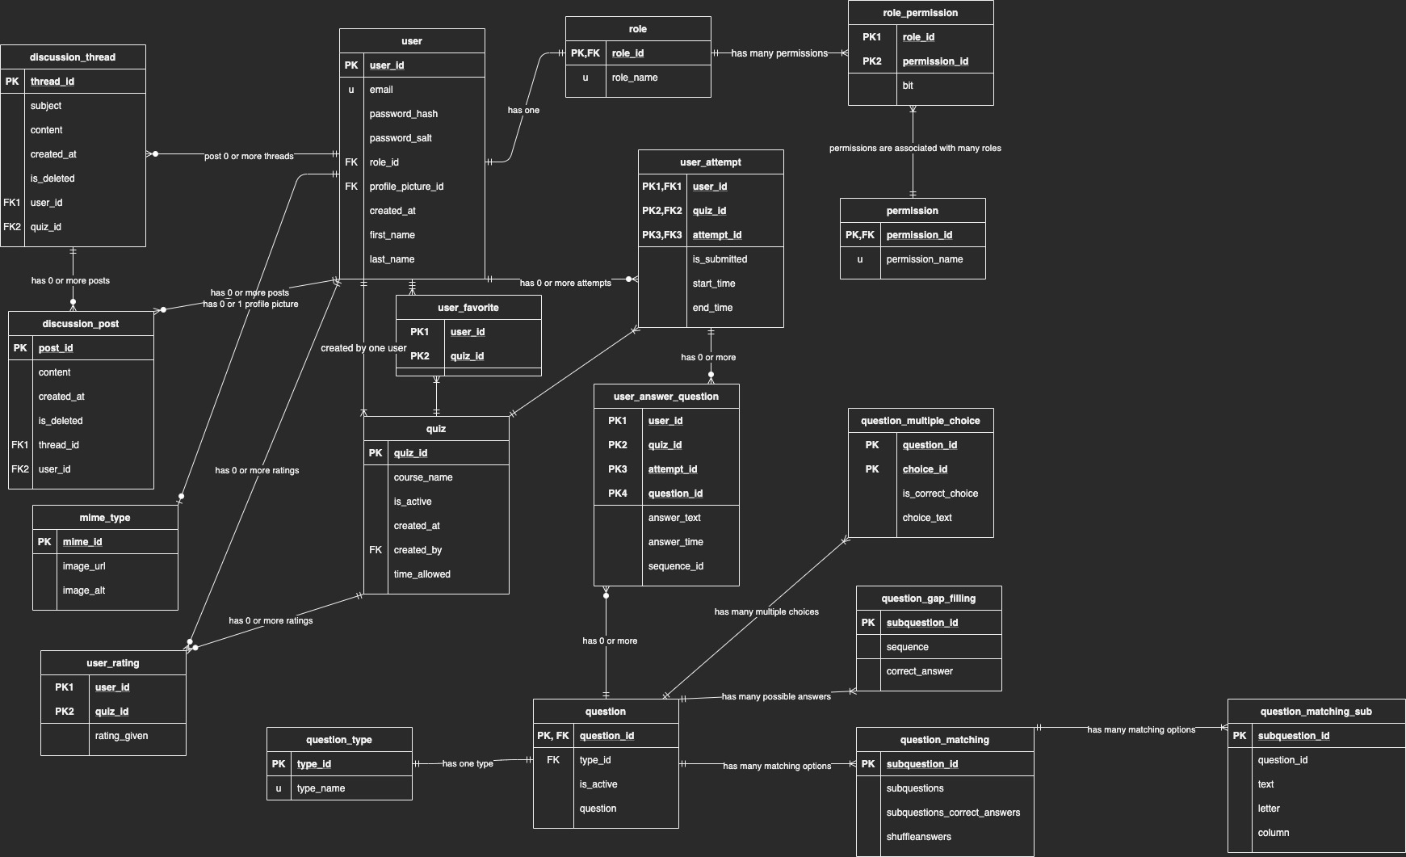

# Test Plan

As for front-end side of the application, Nightwatch is recommended and will perform end-to-end testing for the front-end of the application. Whereas Mocha is responsible for the testing for the back-end side.

## Test to Pass

1. Register a regular user account
2. Verify automatic login successful
3. Log out of the user account
4. Verify user has logged out
5. Log in the account again
6. Verify login successful
7. Start doing a new quiz in the Home screen
8. Verify the quiz screen appears
9. Give random responses for all questions
10. Submit the quiz
11. Verify the quiz result appears
12. Give 4-star rating for the quiz
13. Go back to the Home screen
14. Verify the average rating for the quiz has changed
15. Mark a different quiz as favorite
16. Refresh the Home screen
17. Verify the quiz which has been marked as favorite appears on top
18. Select the Discussion in the navigation bar
19. Verify the Discussion forum appears with threads
20. Click on the “+” button to create a new thread
21. Verify Create New Thread screen shows up
22. Fill in any information for subject and description and select “Quiz 1” for Category dropdown box
23. Select Create Thread
24. Verify a new thread has been created
25. Select the title of the newly created thread
26. Verify Thread Screen shows up
27. Verify all information is matched with the entered information
28. Log out of the regular account
29. Log in an administrator account
30. Select Administration in the navigation bar
31. Verify that the Admin Screen shows up with Admin Panel on the left sidebar
32. Verify that Manage Quizzes has been selected
33. Verify that quizzes are populated in the list in the center of the page
34. Select the delete button of any quiz
35. Verify a warning message pops up
36. Select YES to delete the quiz
37. Verify the quiz has been deleted
38. Select the edit button of any quiz
39. Verify all the information about the quiz has been populated in the editable form below
40. Change the Course Name and select “Save” button
41. Verify that the quiz list above has been updated
42. Select Home in the navigation bar
43. Verify that the changed information is reflected in the Home screen
44. Select Administration in the navigation bar again
45. Now select the edit button of any quiz
46. Click on “Add Question”
47. Verify that “Question Editor” screen appears
48. Select “Multiple Choice” from the dropdown box for “Type”
49. Fill in any information for Instruction and Question
50. Select “Add Choice” three times
51. Verify that three checkboxes have been created
52. Check the first checkbox
53. Select Save
54. Verify that the question has been added to the quiz
55. Select Home in the navigation and select the quiz the question has been just added to
56. Verify the Quiz screen shows up and the newly created question is in there
57. Select the wrong answer and click on Submit
58. Verify that the quiz results screen appears
59. Verify that the given response is incorrect and the correct answer is provided

The testing steps above just go through the most important functionality of the application and has not tested all cases yet.

## Test to Fail

1. Create a regular user with email that has already been taken by another user
2. Log in an account with incorrect password
3. Create a new thread with blank subject and no description
4. Create a new quiz without Course name information
5. Create a multiple choice without checking any of the checkboxes
6. Create a gap-filling question without any gap
7. Create a matching question with some dropdown boxes that have not been filled
8. Update user password to one that is shorter than 8 characters
9. Update first name and last name of user to blank
10. Update email to improper format

# Project Plan Development

|  |  |  |
| --- | --- | --- |
| Week | Date(s) | Tasks |
| 1 | *May 3-7, 2021* | * Start creating dev environment in Visual Studio Code. * Set up GitHub. * Set up MySQL database in MySQL Workbench. |
| 2 | *May 10-14, 2021* | * Start off with creating the database schema based on the schema diagram * Work on the authentication process (Register, Login and Sign out) * Test the site using different roles as different navbars show up. |
| 3 | *May 17-21, 2021* | * Start implementing the Home screen * Write end-to-end test suite for the Home screen * Connect it with the database and write unit test for the back-end side |
| 4 | *May 24-28, 2021* | * Start implementing the Quiz screen with the three different types of questions * Start implementing the Quiz Result after the quiz has been submitted * Write end-to-end test suite for the Quiz screen * Connect it with the database and write unit test for the back-end side |
| 5 | *Jun 5-9 2021* | * Start implementing the Discussion Forum screen * Start implementing the Create Thread and Thread screen * Write end-to-end test suite for the Discussion screen * Connect it with the database and write unit test for the back-end side |
| 6 | *Jun 12-16 2021* | * Start implementing the Thread screen * Write end-to-end test suite for the Discussion screen * Connect it with the database and write unit test for the back-end side |
| 7 | *Jun 19-23 2021* | * Start implementing the Reply to Thread screen * Write end-to-end test suite for the Thread screen * Connect it with the database and write unit test for the back-end side |
| 8 | *Jun 26-30 2021* | * Start implementing the Admin screen * Start implementing the Manage Quizzes screen * Write end-to-end test suite for the Admin and Manage Quizzes screen * Connect it with the database and write unit test for the back-end side |
| 9 | *July 2-6 2021* | * Start implementing the Manage Questions screen * Write end-to-end test suite for the Admin screen * Connect it with the database and write unit test for the back-end side |
| 10 | *July 9-13 2021* | * Go through back end side and make sure the back end and database works well without any issue with data integrity and potential bugs |
| 11 | *July 16-20 2021* | * Go through front-end side and do some design touch-ups |
| 12 | *July 23-27 2021* | * Perform end-to-end testing * Fix any bugs that are found |
| 13 | *July 30-Aug 4 2021* | * Deploy to production on Azure |
| 14 | *Aug 7-11 2021* | * Prepare video demonstration for the finished product and submit the source code along with the video |